
NOTICE OF A COMPLETE APPLICATION AND OF A PUBLIC

MEETING CONCERNING A PROPOSED AMENDMENT TO

ZONING BY-LAW N° 20-2018 (D14-147)

Take notice that the Municipal Council of the Corporation of the Town of Hawkesbury will hold a public meeting on the
12th of November 2024, at 6:00 p.m. at Town Hall, 600 Higginson Street to consider a proposed Amendment to Zoning
By-law N° 20–2018 under Section 34 of the Planning Act, R.S.O. 1990, c.P.13.

The purpose of the application is to rezone Lots 4, 5, 7 and Part of Lot 8, Registered Plan M-21, municipally addressed as 157 and 189 John Street. The applicant is seeking an addition onto the existing building at 189 John Street to add six (6) service bays for the servicing of recreational vehicles. The property is zoned Community Core Commercial (CC) which does not permit recreational vehicle sales and servicing. A Zoning By-law Amendment has been sought to permit recreational vehicle sales and servicing on site.

The property at 157 John Street is proposing to continue using part of the site for storage, and the CC zone does not permit open storage or display. A Zoning Amendment for 157 John Street has been submitted concurrently with the application for 189 John Street to permit outdoor storage and display on site.

The project consists of the construction of six (6) service bays to the existing building at 189 John Street, and to allow open storage and display for the property at 157 John Street. The application to amend Zoning By-law No. 20-2018 will be specific to the property described as Lots 4, 5, 7 and Part of Lot 8, Registered Plan M-21, in the Town of Hawkesbury, County of Prescott.

If a person or public body would otherwise have the ability to appeal the decision of the Council of the Corporation of the Town of Hawkesbury to the Local Planning Appeal Tribunal but the person or public body does not make oral submissions at a public meeting or make written submissions to the Council of the Corporation of the Town of Hawkesbury before the Zoning By-law is passed, the person or public body is not entitled to appeal the decision.

If a person or public body does not make oral submissions at a public meeting, or make written submissions to the Council of the Corporation of the Town of Hawkesbury before the zoning by-law is passed, the person or public body may not be added as a party to the hearing of an appeal before the Local Planning Appeal Tribunal unless, in the opinion of the Tribunal, there are reasonable grounds to do so.

This meeting will take place in person, anyone wishing to attend the meeting must confirm their attendance at the following email address: infoplanning@Hawkesbury.ca, no later than November 8, 2024, at 4:00 p.m. We kindly ask you to send any comments or questions in advance to the above-mentioned email address. This meeting will be available for your view on our YouTube channel a few days after the meeting.

If a person wishes to be notified of the Council of the Corporation of the Town of Hawkesbury’s decision on the proposed Zoning By-law Amendment, they must make a written request to the Planning Department by email at infoplanning@Hawkesbury.ca.

Additional information relating to the proposed amendment to Zoning By-law N° 20–2018 is available to the public by contacting the Town’s Planning Department at the following email: infoplanning@Hawkesbury.ca.

KEY PLAN
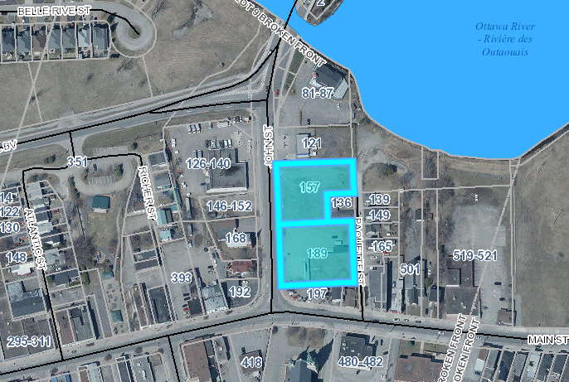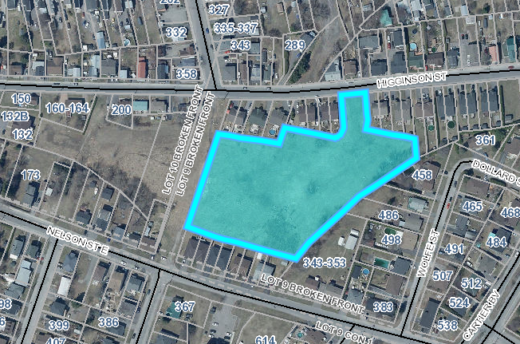
Dated at the Town of Hawkesbury
This 23th day of October 2024

Jillian Simpson, MCIP, RPP
Planner
FOTENN Consultants
simpson@fotenn.ca
www.hawkesbury.ca

Lands targeted by the application.
If the format of this document is inadequate, please contact the Technical Services – Urban Planning at infoplanning@Hawkesbury.ca, and the municipality will provide, to the best of its abilities, the required assistance.

