

NOTICE OF PASSING
OF ZONING BY-LAW N° 72-2024 and N° 73-2024

Date of Decision: December 9, 2024
Date of Notice: December 13, 2024
Last Date of Appeal: December 29, 2024

TAKE NOTICE that the Council of the Town of Hawkesbury passed By-law N° 72-2024 and N° 73-2024 to amend Zoning By-Law N° 20-2018, at a meeting held on December 9, 2024, under Section 17 of the Planning Act, RSO 1990, c. P.13, as amended.

DESCRIPTION OF LANDS: The subject lands are located on the east side of John Street, municipally addressed as 157 and 189 John Street, and described as Lots 4, 5, 7 and Part of Lot 8, Registered Plan M-21. A Key Map is provided below.

THE PURPOSE AND EFFECT OF ZONING BY-LAW AMENDMENT N° 72-2024 AND N° 73-2024: To amend Zoning By-law N° 20-2018 in order to rezone the properties municipally addressed as 157 John Street and 189 John Street to include a site-specific CC-exception Zones for each site.

This includes adding ‘Outdoor Display Area’, ‘Open Storage’, and ‘Open Storage Area’ as permitted uses at 157 John Street to allow for the storage of Recreational Vehicles and to decrease the minimum required setbacks of the ‘Open Storage Area’ to the side and rear lot lines from the required 5 metres to 1 metre.

The site-specific CC-exception Zone for 189 John Street recognizes and permit the existing non-conforming ‘Recreational Vehicle Sales’ use to allow for its expansion to add servicing bays, while also requesting a reduction in the number of loading spaces from 2 spaces to 1 space and permit the required bicycle parking to be located on the abutting lot at 157 John Street.

NOTICE OF RIGHT TO APPEAL
The last date for filing a notice of appeal is December 29, 2024, and a statement that the notice of appeal,
- must be filed with the clerk of the municipality,
- must set out the reasons for the appeal, and
- must be accompanied by the fee of $400.00 required by the Tribunal.

Only individuals, corporations and public bodies may appeal a by-law to the Ontario Land Tribunal. A notice of appeal may not be filed by an unincorporated association or group. However, a notice of appeal may be filed in the name of an individual who is a member of the association or the group on its behalf.

No person or public body shall be added as a party to the hearing of the appeal unless, before the by-law was passed, the person or public body made oral submissions at a public meeting or written submissions to the council or, in the opinion of the Tribunal, there are reasonable grounds to add the person or public body as a party.

EFFECT OF PUBLIC SUBMISSIONS ON THIS DECISION: The Town heard no comments expressed for or against the proposed rezoning of the site.

ADDITIONAL INFORMATION relating to Zoning By-law N° 72-2024 and N° 73-2024 are available for review on the Town’s website at www.hawkesbury.ca

Personal information that accompanies a submission will be collected under the authority of the Planning Act and may form part of the public record, which may be released to the public.

Key Map

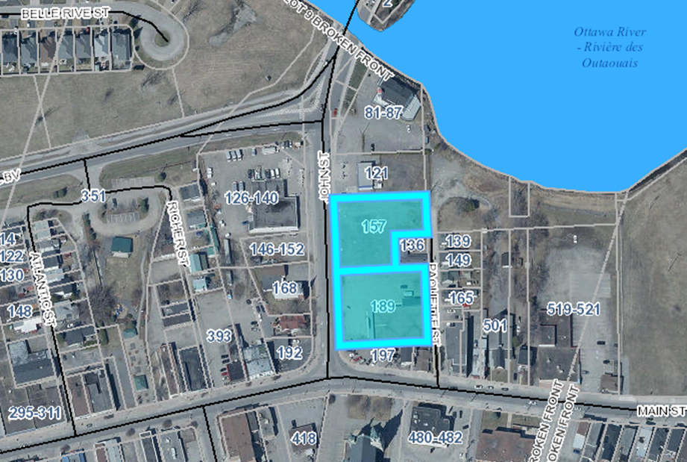

Lands affected by the amendment

DATED AT THE
TOWN OF HAWKESBURY
THIS 13th DAY OF DECEMBER, 2024
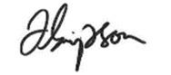

_______________________
Jillian Simpson, MCIP RPP
www.hawkesbury.ca

